VRINDA STORE OBJECTIVE

1. Wants to create an annual sale report for 2022
2. Sample questions

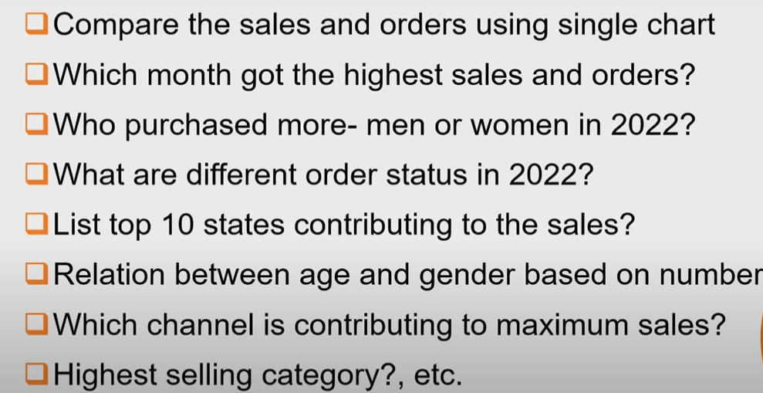

Age group create using age

If(col_no > age ,”senior”,if(col>age,”adult”,”teenager”))

Month column

=TEXT(col, “mmm”) – jan,feb

=TEXT(col,”mmmm”) – January, February

1. Order vs sales pivot chart created
2. From chart we can see highest sales and order
3. Order status – rows , order status count to values
4. States – rows , order id count to values – filter by top 10 states

Connecting with table – using slicers… then right click report connections -> with all tables